A Minor Project-1 Report on

**Hamro Quiz**

Submitted in partial fulfillment of the requirements for the degree of Bachelor of Engineering in Software Engineering at Pokhara University

***By***

**Pramod Gurung**

**Suman Tiwari**

**Kismat Bahadur Chhetri**

**Supervisor**

**Er. Bikash Bhattarai**



**Department of Research and Development**

**GANDAKI COLLEGE OF ENGINEERING AND SCIENCE**

Lamachaur, Kaski, Nepal

**(November 2022)**

# BONAFIDE CERTIFICATE

This is to certify that this project titled **Hamro Quiz** in partial fulfillment of the requirements for the degree of BACHELOR OF ENGINEERING IN SOFTWARE ENGINEERING is a bona fide work of **Suman Tiwari, Pramod Gurung,** and **Kismat Bahadur Chhetri** under the supervision of **Er. Bikash Bhattarai**. It is further certified that this work doesn’t form part of any other project work on the basis of which a degree or award was conferred on any earlier occasion on this by any other candidate.

**Date of Evaluation**: November 13, 2022

|  |  |  |
| --- | --- | --- |
| ……………………………...…  Er. Rajesh Kamar  External Examiner  Assistant Professor  School of Engineering,  Pokhara University |  |  |
|  |  |  |
| ……………………………...…  Er. Bikash Bhattarai  Supervisor |  | ……………………………...…  Er. Rajendra Bahadur Thapa  Project Head  Research Management Cell |

Contents

BONAFIDE CERTIFICATE ii

ACKNOWLEDGMENT 1

ABSTRACT 2

Chapter 1 3

Introduction 3

1.1 Background 3

1.2 Problem Statement 3

1.3 Objectives 3

1.4 Implication 3

Chapter 2 4

Literature Review 4

Chapter 3 5

Methodology and Tools 5

3.1 Flowchart: 5

3.2 Sequence Diagram: 6

3.3 Domain Model Diagram: 7

3.4 ER Diagram: 7

3.5 Use Case Diagram: 8

8

3.6Tools Used in this project: 9

Chapter 4 10

4.1 Expected Output 10

4.2 Future Improvements 10

4.3 Limitations 10

Chapter 5 11

Bibliography 11

CONCLUSION 12

Appendices 13

# ACKNOWLEDGMENT

This project work has been accomplished with the guidance of our supervisor ER. Bikash Bhattarai who have given his full effort in guiding the team in achieving the goal as well as his encouragement to maintain our progress in track. So, we would like to express our sincere gratitude and appreciations to our project head.

We would also like to express our special thanks of gratitude to our principal who gave us the golden opportunity to do this wonderful project on the topic “HAMRO QUIZ”, which helped us in doing a lot of Research and we came to know about many things and many appreciations the crucial role of the GCES staff at the department who provided constructive guidelines, and information during our project work.

Lastly, we are over helmed in all humbleness and gratefulness to acknowledge our depth to all those who have helped us to put these ideas, well above the level of simplicity and into something concrete.

# ABSTRACT

The Quiz application named “Hamro Quiz” is developed to overcome the time-consuming problem of manual system. Apart from that in current system, checking the answer sheets after taking quiz, waste the examiners time, so this application will check the correct answer and save time and carry the quiz in an effective manner.

The aim of this project is to computerized the existing manual system and help the examiner to save their valuable time and important data. This project helps the examiner to manage their service in a good way and provide a better service to the users. This web based application will help different aged group people to increase their knowledge and ability to tackle different scenario’s question in real time. The performance of the application will be fully controlled by Admin. User can see their result after submitting. In this quiz app users can switch between different categories of questions categorized by admin.

# Chapter 1

# Introduction

## 1.1 Background

“Hamro Quiz” is a web-based application with general questions about current affairs and computers. It has multiple choice questions with a time limit and it also calculates scores for each correct answer. It is good for students of every age group it helps in increasing general knowledge about the world, sports, and computers. The application helps the user to increase his or her knowledge.

## 1.2 Problem Statement

The old system of having quizzes was paper-based and was not dynamic. Once the question was printed on the paper, we are unable to quickly change or modify the quiz system. It was unreliable, inaccurate, and more time-consuming.

## 1.3 Objectives

The main objectives of this web-based quiz application named “Hamro Quiz” is:

* To reduce manual efforts.
* To manage the quiz more efficiently.

## 1.4 Implication

The implications of these application are given below

* This application is mostly used in schools, colleges across many quiz contests and also used in online examination system.
* It can offer many advantages to teachers and students to use such system as well as to meet the needs in the field of education.
* It can also make teaching and learning more fun.
* It can be used on Online testing.

# Chapter 2

# Literature Review

* (Xue, 2006), adapted the online examination system using a mode known as "B/W Mode". Web server was used to control the tests and provide information to students. The main goal of the study is to reduce the use of paper and develop a test system that is safe to use. Among the features utilized was only allow the system to be used after receiving the application from student to use it.
* (Perugia), 2008)studied on e-learning in courses at the University of Perugia, known as e-stadium. The study consisted of two stages, through student’s application for online tests or tests that are made directly to students. The study took two years with four semester examinations to graduate students in computer science. Their study focused on the effectiveness of the system used to students. And students are more satisfied in this process.

On Comparing our project with other similar application, we come to conclude with following.

|  |  |  |  |
| --- | --- | --- | --- |
| **Features** | **Quiz Faber** | **Easy Test Maker** | **Hamro Quiz** |
| **Better User interface** | NO | NO | YES |
| **Login System** | NO | YES | YES |
| **More informative** | YES | NO | YES |

# Chapter 3

# Methodology and Tools

### 3.1 Flowchart:

Fig: Flowchart Diagram of Hamro Quiz

This is the flowchart of our quiz app named “Hamro Quiz”. This flowchart describes our step-by-step procedure of solving problem during quiz.

Start: Quiz program start

Main Menu: Program display menu to the user to start the game or to quit.

User Input: The application stops to get user input.

Decision Tree: If user input is S then Quiz game start else if user input is Q then the program will quit.

Quiz Game: User gets 10 questions one by one and each correct score is marked as 1.

Display Score: It display final score after ending the game and the user is directed to the main menu.

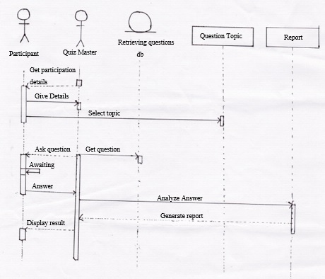Stop: End of the game.

### 3.2 Sequence Diagram:

Fig: Sequence Diagram of Hamro Quiz

### 3.3 Domain Model Diagram:

Fig: Domain Model Diagram of Hamro Quiz

7

### 3.4 ER Diagram:

Fig: ER Diagram of Hamro Quiz

3.5 Use Case Diagram:

### 

Fig: Use Case Diagram of Hamro Quiz

This Use Case diagram describes the interaction between the system and its actor. Here there are two actors named “participant” and “quiz master”. The participant registers its information in the system but the quiz master not only registers its information into the system it also prepares questions for the participant manages questions according to the preference of the user and also delivers score and report for the quiz.

### 3.6Tools Used in this project:

* HTML, CSS, JavaScript, PHP and MySQL
* Sublime text as Text editor
* Bootstrap

# Chapter 4

## 4.1 Expected Output

* Web-based application.
* The main goal of this web-based application is to enable user to practice for subjective tests.

## 4.2 Future Improvements

* Optimization of the system.
* Addition of new features and functionalities.

## 4.3 Limitations

* Internet access is required
* Technical person is needed to manage the system

# Chapter 5

# Bibliography

Academia.edu. (n.d.). *Academia.edu*. Retrieved from Academia.edu: Academia.edu

Advance Informatics School, K. L. (n.d.). *researchgate.net*. Retrieved from researchgate.net: researchgate.net

codeincodeblocks.com. (n.d.). *codeincodeblocks.com*. Retrieved from codeincodeblocks.com: codeincodeblocks.com

javapoint.com. (n.d.). *javapoint.com*. Retrieved from javapoint.com: javapoint.com

Oracle. (n.d.). *docs.Oracle.com*. Retrieved from docs.Oracle.com: docs.Oracle.com

Perugia), J. (. (2008). *researchgate.net*. Retrieved from researchgate.net: researchgate.net

tuotorialspoints.com. (n.d.). *tuotorialspoints.com*. Retrieved from tuotorialspoints.com: tuotorialspoints.com

tutorialpoints.com. (n.d.). *tutorialpoints.com*. Retrieved from tutorialpoints.com: tutorialpoints.com

Xue. (2006). *researchgate.net*. Retrieved from researchgate.net: researchgate.net

# CONCLUSION

“Hamro Quiz” is a web-based application with general questions about current affairs and computers. It has multiple choice questions with a time limit and it also calculates scores for each correct answer. This web application provides a platform for check the general and basic knowledge .admin can manage data of system. Users as a guest and participate the Quiz and test their skills.

# Appendices

**LOGIN PAGE**



**DASHBOARD**

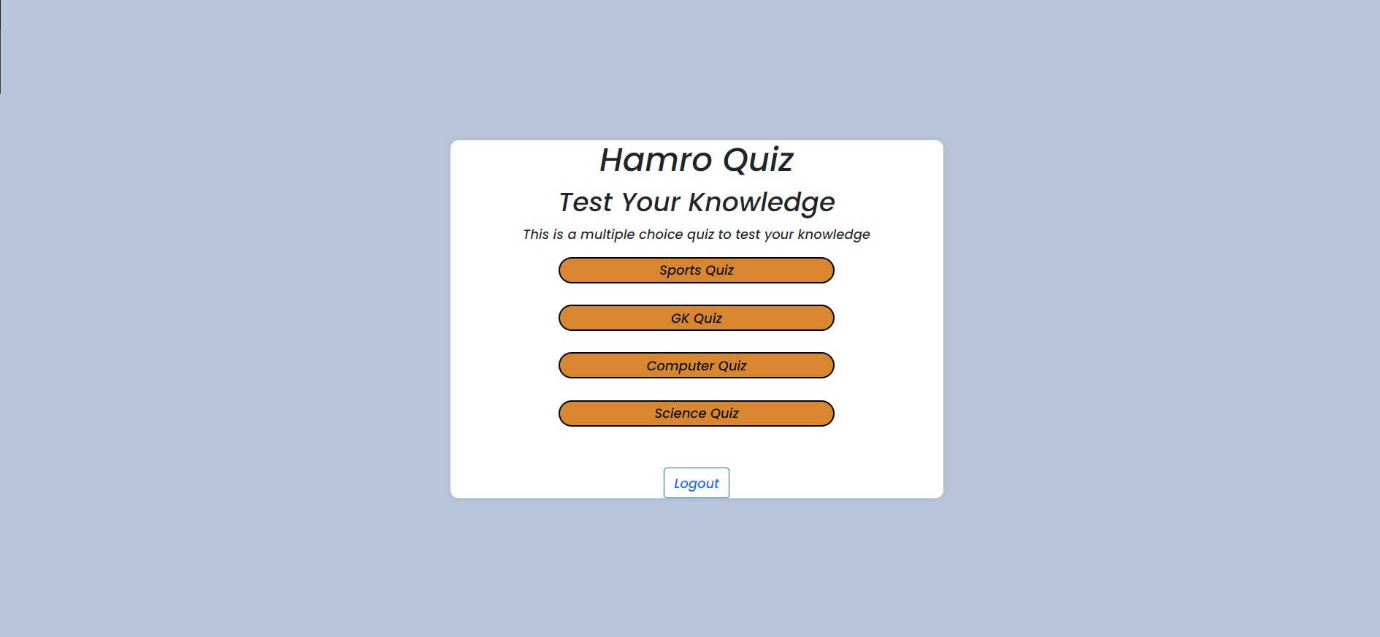

**QUIZ PAGE**

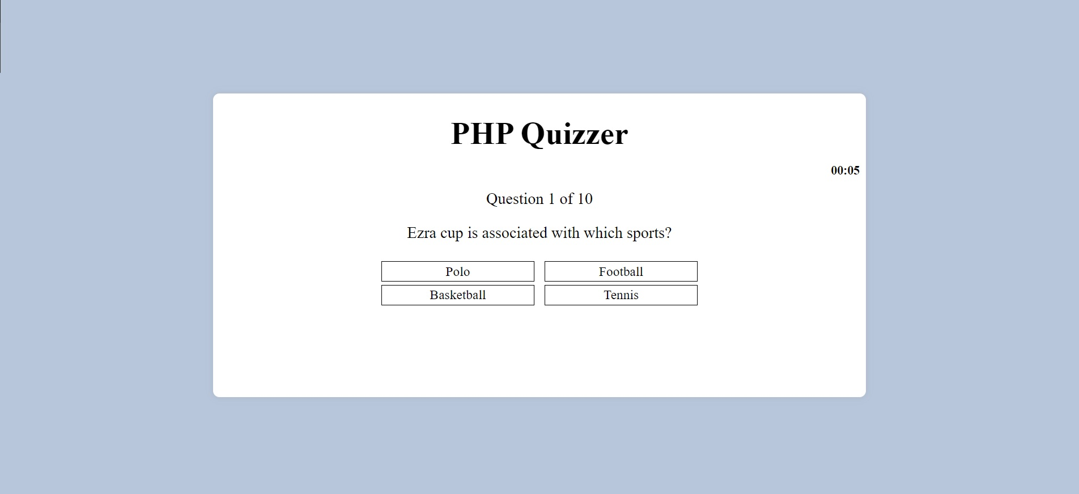

**FINAL PAGE**



TAKE AGAIN